U.S. Department of Commerce
ONMS succession number to be inserted by staff
Insert cover image
Title in Times New Roman, 24, bolded
MONTH YEAR | sanctuaries.noaa.gov | National Marine Sanctuaries Conservation Science Series ONMS-1X-XX

Title

Wilbur Ross, Secretary

National Oceanic andAtmospheric Administration
Neil A. Jacobs, Ph.D.
Assistant Secretary of Commerce for Environmental Observation and Prediction

National Ocean Service
Nicole LeBoeuf, Assistant Administrator (Acting)

Office of National Marine Sanctuaries
John Armor, Director

Report Authors:

Suggested Citation:
Suggested citation for this publication.

Cover Photo:
Cover photo(s) caption and credit here.

About the National
Marine Sanctuaries Conservation Series

The Office of National Marine Sanctuaries, part of the National Oceanic and Atmospheric Administration, serves as the trustee for a system of underwater parks encompassing more than 600,000 square miles of ocean and Great Lakes waters. The 13 national marine sanctuaries and two marine national monuments within the National Marine Sanctuary System represent areas of America’s ocean and Great Lakes environment that are of special national significance. Within their waters, giant humpback whales breed and calve their young, coral colonies flourish, and shipwrecks tell stories of our nation’s maritime history. Habitats include beautiful coral reefs, lush kelp forests, whale migration corridors, spectacular deep-sea canyons, and underwater archaeological sites. These special places also provide homes to thousands of unique or endangered species and are important to America’s cultural heritage. Sites range in size from less than one square mile to almost 583,000 square miles. They serve as natural classrooms and cherished recreational spots, and are home to valuable commercial industries.

Because of considerable differences in settings, resources, and threats, each marine sanctuary has a tailored management plan. Conservation, education, research, monitoring and enforcement programs vary accordingly. The integration of these programs is fundamental to marine protected area management. The Marine Sanctuaries Conservation Series reflects and supports this integration by providing a forum for publication and discussion of the complex issues currently facing the sanctuary system. Topics of published reports vary substantially and may include descriptions of educational programs, discussions on resource management issues, and results of scientific research and monitoring projects. The series facilitates integration of natural sciences, socioeconomic and cultural sciences, education, and policy development to accomplish the diverse needs of NOAA’s resource protection mandate. All publications are available on the Office of National Marine Sanctuaries website (http://www.sanctuaries.noaa.gov).

Disclaimer

Report content does not necessarily reflect the views and policies of the Office of National Marine Sanctuaries or the National Oceanic and Atmospheric Administration, nor does the mention of trade names or commercial products constitute endorsement or recommendation for use.

Report Availability

Electronic copies of this report may be downloaded from the Office of National Marine Sanctuaries website at http://sanctuaries.noaa.gov.

Contact

Contact information here.

Table of content must be hyperlinked to relevant sections in the report.
Table of Contents

Abstract iv
Key Words iv
Chapter 1 1
Chapter 2 3
Chapter 3 6
Chapter 4 …18
Acknowledgements 19
Glossary of Acronyms 20
Literature Cited 21
Appendix 22

Abstract

Abstract text here.
All text in body of report should be Times New Roman, 12

Key Words

Key words here.

Chapter 1
Chapter titles must be hyperlinked to the table of contents. Chapter titles should be in Arial font, all caps, bold.

CHAPTER TITLE

Text and graphics for Chapter 1 here. Text and graphics for Chapter 1 here. Text and graphics for Chapter 1 here. Text and graphics for Chapter 1 here. Text and graphics for Chapter 1 here. Text and graphics for Chapter 1 here. Text and graphics for Chapter 1 here. Text and graphics for Chapter 1 here. Text and graphics for Chapter 1 here. Text and graphics for Chapter 1 here. Text and graphics for Chapter 1 here. Text and graphics for Chapter 1 here. Text and graphics for Chapter 1 here. Text and graphics for Chapter 1 here. Text and graphics for Chapter 1 here. Text and graphics for Chapter 1 here. Text and graphics for Chapter 1 here. Text and graphics for Chapter 1 here. Text and graphics for Chapter 1 here. Text and graphics for Chapter 1 here. Text and graphics for Chapter 1 here. Text and graphics for Chapter 1 here. Text and graphics for Chapter 1 here. Text and graphics for Chapter 1 here. Text and graphics for Chapter 1 here. Text and graphics for Chapter 1 here.

Chapter 2
Chapter title

Text and graphics for Chapter 2 here. Text and graphics for Chapter 2 here. Text and graphics for Chapter 2 here. Text and graphics for Chapter 2 here. Text and graphics for Chapter 2 here. Text and graphics for Chapter 2 here. Text and graphics for Chapter 2 here. Text and graphics for Chapter 2 here. Text and graphics for Chapter 2 here. Text and graphics for Chapter 2 here. Text and graphics for Chapter 2 here. Text and graphics for Chapter 2 here. Text and graphics for Chapter 2 here. Text and graphics for Chapter 2 here. Text and graphics for Chapter 2 here. Text and graphics for Chapter 2 here. Text and graphics for Chapter 2 here. Text and graphics for Chapter 2 here. Text and graphics for Chapter 2 here. Text and graphics for Chapter 2 here. Text and graphics for Chapter 2 here.

Chapter 3

CHAPTER TITLE

Text and graphics for chapter 3 here. Text and graphics for chapter 3 here. Text and graphics for chapter 3 here. Text and graphics for chapter 3 here. Text and graphics for chapter 3 here. Text and graphics for chapter 3 here. Text and graphics for chapter 3 here. Text and graphics for chapter 3 here. Text and graphics for chapter 3 here. Text and graphics for chapter 3 here. Text and graphics for chapter 3 here. Text and graphics for chapter 3 here. Text and graphics for chapter 3 here. Text and graphics for chapter 3 here.
Text and graphics for chapter 3 here. Text and graphics for chapter 3 here. Text and graphics for chapter 3 here. Text and graphics for chapter 3 here. Text and graphics for chapter 3 here. Text and graphics for chapter 3 here.

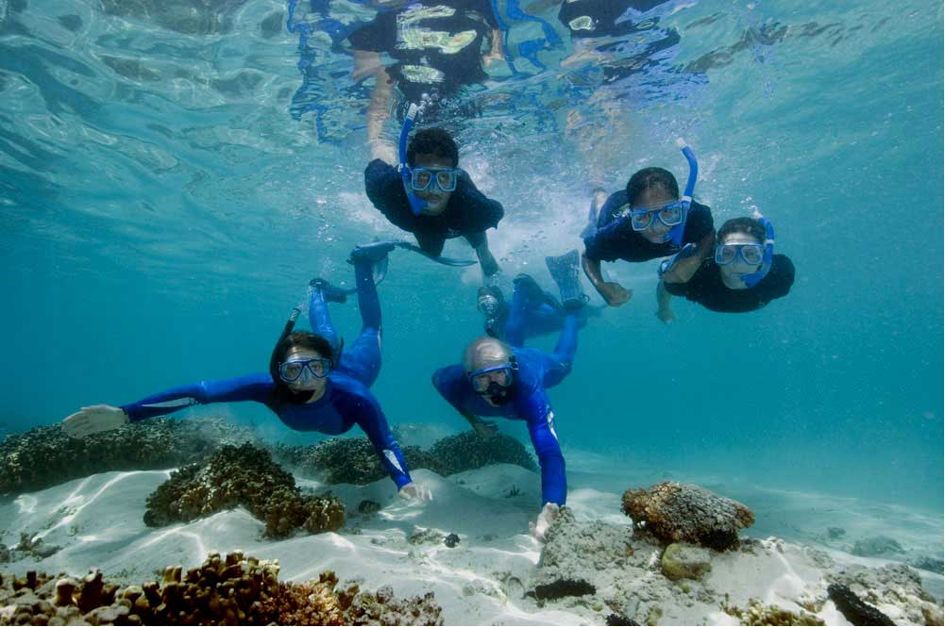
If including photos, make sure to include captions and photo credits. Captions should be Arial font, size 9.
Header | Header | Header
Text | Text | Text
Text | Text | Text
Table a. Description of table goes here.
Centered, Arial
For tables: Description of table above cells, Arial font, size 9. Text in table, Arial font
Photo caption goes under photo. (Photo: First Name Last Name/Affiliation)

Acknowledgements

We would like to thank … Finally, we also thank the anonymous peer reviewers of this report.

Glossary of Acronyms

If needed, glossary of acronyms here.

Literature Cited

Literature cited within document.

Appendix

If needed, appendix text here.

