Title goes here, Font =
Trajan Pro Bold or Arial Bold
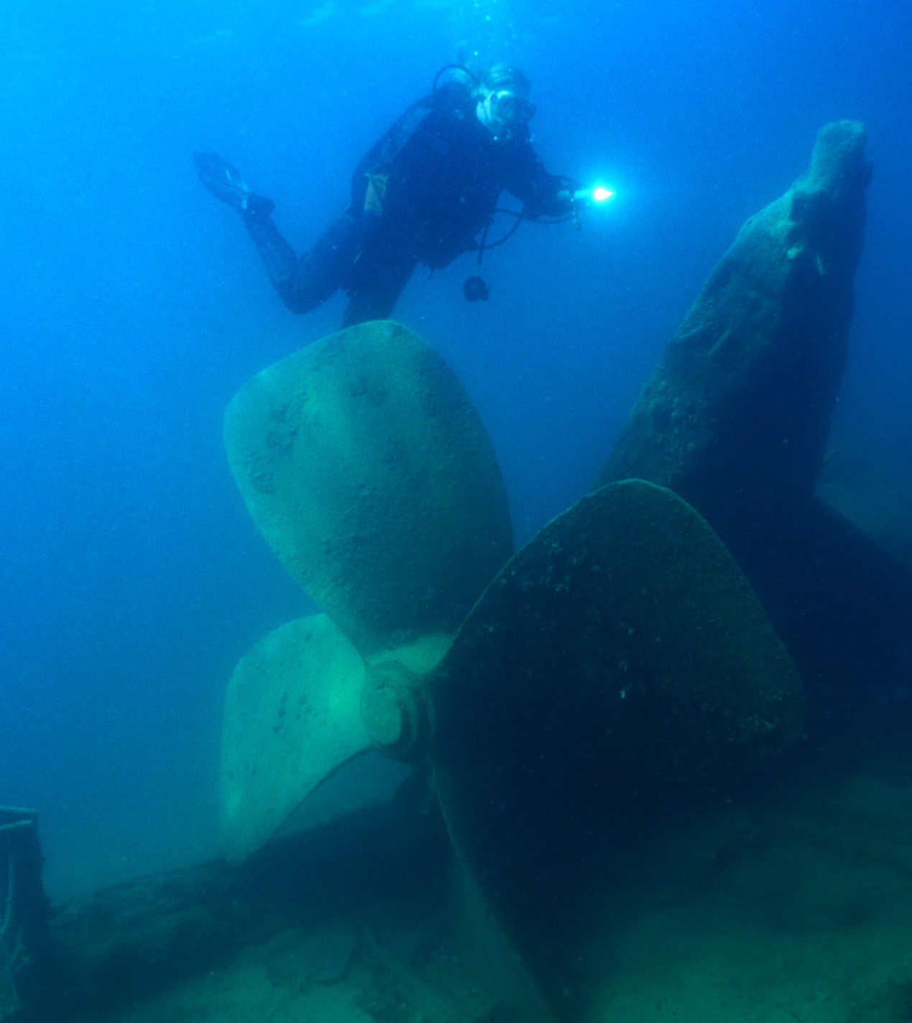
First Step: Save this document with a new name. This allows you to always have the original document for reference & instructions.

All images in the document should be formatted “in line with text” to make them accessible. To make sure they are “in line,” select the picture and then click “Format.” Then click “Wrap Text,” “In Line with Text.” As a shortcut on a PC, select the picture and a “Layout Options” box will pop up. You can use this option to change text wrapping to “In Line with Text.”
Make sure to also add alt text to images for accessibility. For more accessibility information review the Best Practices for Accessibility.

ONMS Succession number will be inserted by HQ staff.

MONTH YEAR | sanctuaries.noaa.gov
National Marine Sanctuaries Conservation Science Series ONMS-1X-XX
TO REPLACE AND RESIZE COVER GRAPHICS (Previous Page)
- Select image. When the picture format tab pops up, click it. Then click “Change Picture,” then “From a file.” You can also get to “Change Picture” from right clicking on the photo.
- Find and select desired graphic using the dialog box that automatically appears. Click “Insert” button the bottom of the dialog box. Image will then appear in your document where the other photo was placed.
- To expand the size of the photo: select and drag the tiny boxes on the corners of the photo. Do not resize by only moving the middle boxes. When resizing, make sure the photo stays in the correct proportions.

U.S. Department of Commerce
Wilbur Ross, Secretary
National Oceanic and Atmospheric Administration
Neil A. Jacobs, Ph.D.
Assistant Secretary of Commerce for Environmental Observation and Prediction
Performing the duties of Under Secretary of Commerce for Oceans and Atmosphere
This page is the inside cover, a great place for credit information, address info, publication date, etc. It is also a great place our logos, and the best option for partner logos unless it is imperative to put them on the front cover.
National Ocean Service
Nicole LeBoeuf, Assistant Administrator (Acting)
Office of National Marine Sanctuaries
John Armor, Director

Suggested citation: Suggested citation for this publication should go here.
Cover photo: Cover photo caption and credit should go here.

About the National Marine Sanctuaries
Conservation Series
The Office of National Marine Sanctuaries, part of the National Oceanic and Atmospheric Administration, serves as the trustee for a system of underwater parks encompassing more than 600,000 square miles of ocean and Great Lakes waters. The 14 national marine sanctuaries and two marine national monuments within the National Marine Sanctuary System represent areas of America’s ocean and Great Lakes environment that are of special national significance. Within their waters, giant humpback whales breed and calve their young, coral colonies flourish, and shipwrecks tell stories of our nation’s maritime history. Habitats include beautiful coral reefs, lush kelp forests, whale migration corridors, spectacular deep-sea canyons, and underwater archaeological sites. These special places also provide homes to thousands of unique or endangered species and are important to America’s cultural heritage. Sites range in size from less than one square mile to almost 583,000 square miles. They serve as natural classrooms and cherished recreational spots, and are home to valuable commercial industries.
Because of considerable differences in settings, resources, and threats, each national marine sanctuary has a tailored management plan. Conservation, education, research, monitoring, and enforcement programs vary accordingly. The integration of these programs is fundamental to marine protected area management. The National Marine Sanctuaries Conservation Series reflects and supports this integration by providing a forum for publication and discussion of the complex issues currently facing the National Marine Sanctuary System. Topics of published reports vary substantially and may include descriptions of educational programs, discussions on resource management issues, and results of scientific research and monitoring projects. The series facilitates integration of natural sciences, socioeconomic and cultural sciences, education, and policy development to accomplish the diverse needs of NOAA’s resource protection mandate. All publications are available on the Office of National Marine Sanctuaries website (http://www.sanctuaries.noaa.gov).

Disclaimer
The scientific results and conclusions, as well as any views or opinions expressed herein, are those of the authors and do not necessarily reflect the views of NOAA or the Department of Commerce. The mention of trade names or commercial products does not constitute endorsement or recommendation for use.

Report Availability
Electronic copies of this report may be downloaded from the Office of National Marine Sanctuaries website at http://sanctuaries.noaa.gov.

Contact
Contact information here.

Table of Contents
About the National Marine Sanctuaries Conservation Series i
Disclaimer ii
Report Availability ii
Contact ii
Table of Contents iii
Abstract iv
Key Words iv
Chapter 1: HEADING 1 1
ONMS Heading 2 2
ONMS Heading 3 2
Chapter 2: HEADING 1 3
ONMS Heading 2 3
ONMS Heading 3 3
Acknowledgements 4
Glossary of Acronyms 5
Literature Cited 6
APPENDIX A: Appendix Title in Heading 1 Style 7

Styles have been created for all text and heading levels. A style is a predetermined look for a paragraph (i.e. font, font spacing, bold, non-bold, font color, tab spacing, etc.).
The styles can be found by clicking the “Home” tab, then in the “Styles” section. If you want to see all of the Styles available, click the small box in the bottom right corner of the Styles section. Or you can hit Alt+Ctrl+Shift+S. If you are on a Mac, click “Styles Pane” on the Home tab. Once the Styles Pane pops up, you will be able to see the different styles available for the document.
When you are ready to utilize the styles, simply place your cursor in the desired paragraph, and then click on a style option in the Styles section.
To see what style is assigned to any section below, click on the text and the assigned style will be highlighted in the Styles section of the Home tab.

Abstract
Abstract text should go here.

Key Words
If you have key words for your document, include them here.

The document is broken into different sections so you can have a different header for each chapter if you want to. Also, this way you can change the page numbers from Roman numerals on the intro pages to numbers on the chapter pages.
To add a new section, go to the “Layouts” tab, click “Breaks.” Then, go down to “Section Breaks” and click “Next Page.” This will start a new section on the next page. Visit Microsoft’s website for more information on section breaks.

Chapter 1:
HEADING 1
Each different section can have a different header. To change the header per section, click “Insert,” then “Header,” and then “Edit Header.” You can also double click in the header area to open the header options. Once you have the header open, before you edit the text, click “Link to Previous” in the header ribbon so that it is not highlighted. Now, if you change the header in this section, it will only be for this section.

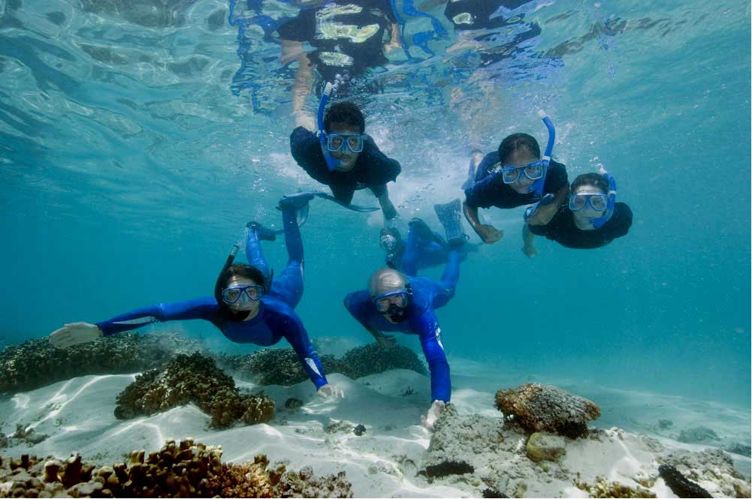
All images in the document should be formatted “in line with text” to make them accessible. To make sure they are “in line,” select the picture and then click “Format.” Then click “Wrap Text,” “In Line with Text.” As a shortcut on a PC, select the picture and a “Layout Options” box will pop up. You can use this option to change text wrapping to “In Line with Text.”
Make sure to also add alt text to images for accessibility. For more accessibility information review the Best Practices for Accessibility.
Photo on chapter page is optional – If no photo, chapter content starts below chapter title instead of photo. Photo caption goes under photo if used. This is the “Photo Caption” paragraph style, which can be found under the “home” tab, then select “Styles.” Photo caption should be a full sentence. Add photo credit at end of caption, without parentheses, in the following format: Photo: Name/Affiliation

Text and graphics for Chapter 1 here. This is the “Normal” paragraph style. Simply click the “Normal” paragraph style in the Styles section of the Home tab.
Text and graphics for Chapter 1 here. Text and graphics for Chapter 1 here. Text and graphics for Chapter 1 here. Text and graphics for Chapter 1 here. Text and graphics for Chapter 1 here. Text and graphics for Chapter 1 here. Text and graphics for Chapter 1 here. Text and graphics for Chapter 1 here. Text and graphics for Chapter 1 here. Text and graphics for Chapter 1 here. Text and graphics for Chapter 1 here. Text and graphics for Chapter 1 here. Text and graphics for Chapter 1 here. Text and graphics for Chapter 1 here. Text and graphics for Chapter 1 here. Text and graphics for Chapter 1 here. Text and graphics for Chapter 1 here. Text and graphics for Chapter 1 here. Text and graphics for Chapter 1 here. Text and graphics for Chapter 1 here. Text and graphics for Chapter 1 here. Text and graphics for Chapter 1 here. Text and graphics for Chapter 1 here. Text and graphics for Chapter 1 here. Text and graphics for Chapter 1 here.

ONMS Heading 2

ONMS Heading 3

ONMS Heading 4

ONMS Heading 5

ONMS Heading 6
This is the “Normal” paragraph style. Simply click the “Normal” paragraph style in the Styles section of the Home tab.
If you need to add a footnote, go to “References,” then “insert footnote.”
If you need to add a table, click “Insert,” then “Table” and determine the size of your table.
Table 1. Table caption should go above the table in the “Photo Caption” paragraph style found in the Styles section. For the table text, highlight the text and click the “Table Text” style found in the Styles section.
Table Text | Table Text | Table Text | Table Text
Table Text | Table Text | Table Text | Table Text
** Note: If tables will be larger than one page, highlight the top (header) row of the table. In the “Table Tools” tab, select the “Layout” tab and “Properties.” In the “Table Properties” box, select the “Row” tab. Under “Options,” make sure “Allow row to break across pages” is NOT selected and “Repeat as header row at the top of each page” is selected. This will ensure that the table is formatted correctly over multiple pages.
Styles have been created for all the different levels of title headers, captions and credits, main text, etc. See the yellow instructions on the TOC page for more info about styles.

Chapter 2:
HEADING 1

ONMS Heading 2

ONMS Heading 3

ONMS Heading 4

ONMS Heading 5

ONMS Heading 6
This is the “Normal” paragraph style. Click the “Normal” paragraph style in the Styles section of the Home tab.

Acknowledgements
We would like to thank … Finally, we also thank the anonymous peer reviewers of this report.

Glossary of Acronyms
If needed, add your list of acronyms here. General rule of thumb: if you have 10 or less acronyms within your document, you do not need a glossary of acronyms unless you want to add them. If the document has more than 10 acronyms, add a glossary. Make sure you really need the acronym before using in the document.

Literature Cited
Add references here. Use the “Bibliography” paragraph style which can be found in the Styles section of the Home tab.

APPENDIX A:
Appendix Title in Heading 1 Style
If needed, include an appendices after your list of references. This is the Normal paragraph style.

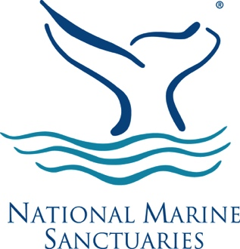
A final section has been created for the back cover. This way, there will be no header or footer on the back cover.

Once you have inserted a footnote in the text above, you can edit your footnote text here. For footnote style click the “Footnote Text” paragraph style in the Styles section, found under the Home tab.

